**Raymond You**

**Pre-Lab Assignment 2**

**Professor Kimani**

**a)**

#!/bin/bash

# input-user.bash

echo -n "Enter name for directory:"

read -r name

mkdir "$name"

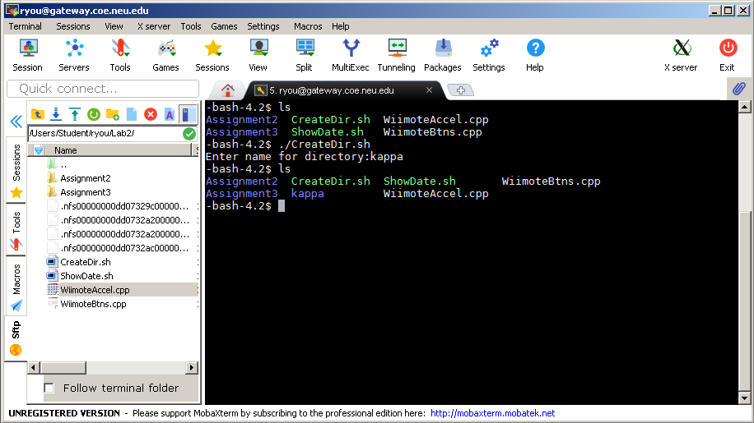

**b)**

#!/bin/bash

date=`date +"%a %b %d %T %Z %Y"`

echo -n "The current date is $date "

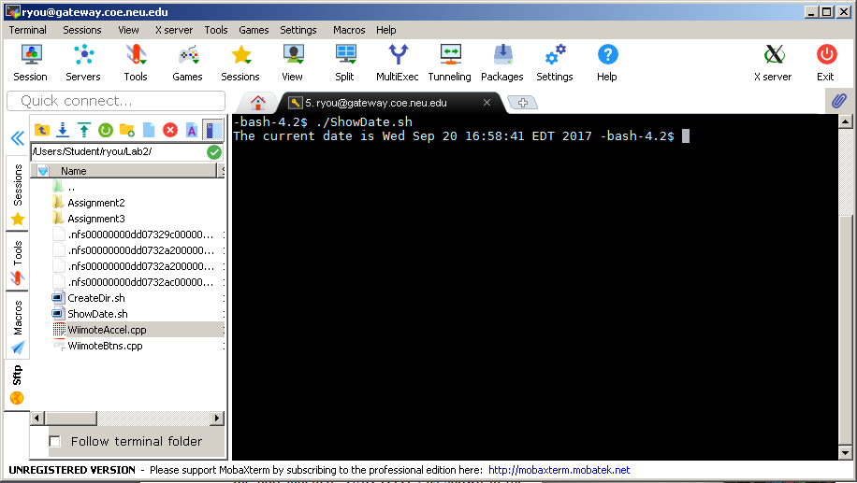

**c)**

#include <stdlib.h>

#include <fcntl.h>

#include <unistd.h>

#include <iostream>

class WiimoteBtns {

private:

// Open Wiimote event file

int fd;

public:

WiimoteBtns() {

fd = open("/dev/input/event2", O_RDONLY);

if (fd == -1)

{

std::cerr << "Error: Could not open event file - forgot sudo?\n";

exit(1);

}

}

~WiimoteBtns() {

close(fd);

}

void Listen() {

while (true)

{

// Read a packet of 32 bytes from Wiimote

char buffer[32];

read(fd, buffer, 32);

// Extract code (byte 10) and value (byte 12) from packet

int code = buffer[10];

int value = buffer[12];

ButtonEvent(code, value);

}

}

void ButtonEvent(int code, int value) {

// Print them

std::cout << "Code = " << code << ", value = " << value << '\n';

}

};

int main() {

WiimoteBtns *btns = new WiimoteBtns();

btns->Listen();

}

**d)**

#include <stdlib.h>

#include <fcntl.h>

#include <unistd.h>

#include <iostream>

class WiimoteAccel {

private:

// Open Wiimote event file

int fd;

public:

WiimoteAccel() {

fd = open("/dev/input/event0", O_RDONLY);

if (fd == -1)

{

std::cerr << "Error: Could not open event file - forgot sudo?\n";

exit(1);

}

}

~WiimoteAccel() {

close(fd);

}

void Listen() {

while (true)

{

// Read a packet of 16 bytes from Wiimote

char buffer[16];

read(fd, buffer, 16);

// Extract code (byte 10) and value (byte 12) from packet

int code = buffer[10];

short acceleration = * (short *) (buffer + 12);

ButtonEvent(code, acceleration);

}

}

void ButtonEvent(int code, int acceleration) {

// Print them

std::cout << "Code = " << code << ", acceleration = " << acceleration << '\n';

}

};

int main() {

WiimoteAccel *accel = new WiimoteAccel();

accel->Listen();

}